SaLES PROPOSAL

PrePared By:
Realtime Trading PVT. LTD.
New Baneswor, Kathmandu
Nepal

OVERVIEW AND GOALS
Realtime trading's property management cloud based system is scalable, robust, and performs consistently well over time. As a fundamental part of your cloud-based software, it will improve your organization's productivity and efficiency and meet your unique organizational needs through its customizable suite of programs that support:
- property management
- ability to manage tenant lease
- management of assets provided to the tenant
- generate automatic periodic invoices to the tenant
- generate convenient reports of the property
- online access to tenant, service providers and your employee
- security management and communication
- online payment

We know that system is a big investment. Choosing Realtime trading exclusive products and services means you get access to two decades of industry expertise and a commitment to quality that will pay off many times over - today and down the road, wherever that road takes you.

WHY Property Care GURU?
Propertycareguru is not just about displaying, using, and storing large amounts of data. And it's not as simple as establishing automatic business processes, or making sure report of accounting and customer service can peacefully co-exist.
The right system for your company is more than just the sum of its parts. It's an overarching work environment that supports both your practical business functions and your unique company's culture.
At Realtime trading, our team of experts has been building cloud-based system for a long time and we've seen it all. No problem is too big, or too small. And nothing makes us happier than solving them.

SCOPE OF SERVICES
The most important things when choosing propertycareguru are lease management, property management, management information system, and property's business marketing.
Lease Management
Propertycareguru helps to optimize your leasing and renter managment activities. The application makes it easy to set up and track the schedule for rent increased based on the terms of each lease. Once scheduled, future monthly charges will be adjusted to reflect these changes task management with propertycareguru activities can be created for properties, units and occupancies, allowing you to stay organized and get things done more efficiently.
Property Management
There’s a lot on your plate as a property manager. That’s why you need a solution that’s flexible, integrated and streamlines the entire property management process in one place. When you manage your properties in Property care guru, you have an offering that’s secure, reliable and cost-effective, so that you can grow your business.

Management Information System
The truth is that you can have all the features in the world and they wouldn’t matter if your information system doesn’t function properly—this is the heart of your company. Our Property Manager offers robust property management accounting report with real-time flexible reporting so you can feel confident everything in your business is running smoothly.

Business Marketing
There are a variety of websites and social networks that business owners can choose to display their advertising. But reaching the right audience using targeted display ads can be difficult, and banner advertising can be expensive. Automatically list your space on our listings page and gain access to a large user-base instantaneously.

OUR TEAM
Amin Rajbhandari,
Chairperson
Dip Rajbhandari,
Consultant

Nirija Shrestha,
Project Manager

Abishek Shrestha
Sales Executive

YOUR INVESTMENT

Our fees are based on the number of units of your property and will be billed on the monthly basis for the contract period from the date of the contract.
We have the three types of pricing for the use of the system.
- Silver
- Gold
- Premium
The pricing is based on the features that you choose for your system.
You can view the detail features listing of the system pricing in our system. You can view the price lists from http://propertycareguru.com/pricing.
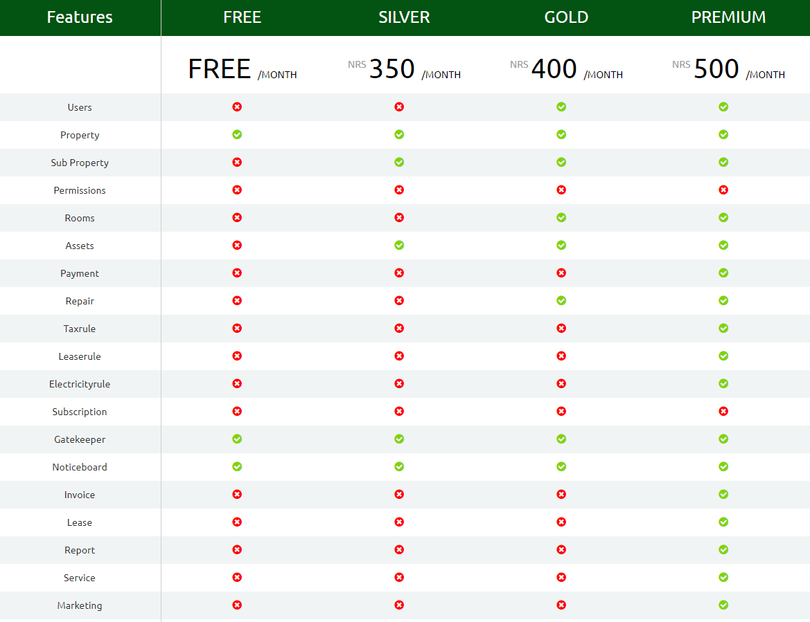

SIGNATURE

- If you have any questions at all, please let us know. We're happy to clarify any points and there may be some items that we can sort out together. We're committed to finding the best way to work together.
- Once you feel confident about everything and are ready to move forward, please click the 'sign here' button below.
- Once we receive notification of your acceptance, we'll contact you shortly to sort out next steps and get the project rolling.
- If you'd like to speak to us by phone, don't hesitate to call 977-1-4785245/ 4785344

________________________________________
Abhishek Shrestha
Sales Executive
Realtime Trading Pvt. Ltd.

________________________________________
(Customer Company)

